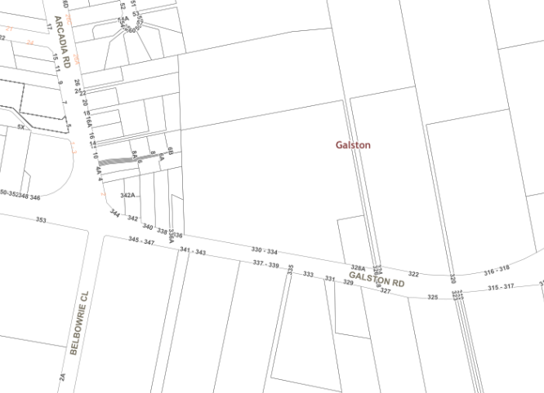

**LOCALITY PLAN**

**DA/850/2011/B**

**330-334 Galston Road, Galston**